SPORTS STATION

Provider

By

Karan

Level-6

Final Project

Table of Contents

Project Proposal 3

Goals and Objectives 3

Project Scope 3

Project Specifications 3

Target Audience 3

Project Deliverables 4

Resource Requirements 4

Project Tasks and Milestones 4

Project Assumptions 5

Project Report 5

Detail Design 6

Home Page 6

Registration Page 6

Login Page 7

Sports Material Admin View 7

Sports Categories Admin View 8

All Sports Categories Visitor View 8

All Sports Material Visitor View 9

Sports Order History Page Visitor View 9

Project Testing 10

User Manual 10

Summary 10

System Configuration 10

User Access Levels 10

# 

# 

# Project Proposal

## Goals and Objectives

The main goal or aim of the project is to implement an online web application named “Sports Station”. The main purpose of the application is help people to find sports material required in game and capable to place bulk order. In this application there are two types of users- admin and registered visitor. Admin has different functionalities as compare to registered visitor. Admin can add, edit, delete and check details of all sports categories, Sports Brands and Sports Material. Admin can also view the all-order history place on web application. Registered visitor is capable to place bulk order.

## Project Scope

The scope of this project is to implement an app named “Sports Station” with the help of which user can find any sports playing material and place their bulk orders. The duration of the project is 20 working days which is equals to 4 weeks.

## Project Specifications

* Admin login/logout
* Add, edit, delete and check details of sports categories, sports Brands and sports material details by admin.
* Admin can delete, edit and check bulk order history
* Admin can register new admins.
* Registered Visitor can login/logout.
* New Visitor can register.
* Visitor can place bulk order according to their choice.

## Target Audience

The target audience for this project is the seeker who would like to interested in bulk order of sports material. The age can go from 20 plus to 60 plus.

## Project Deliverables

The deliverables of the project are:

|  |  |
| --- | --- |
| **Deliverable** | **Description** |
| Final Report | This will be the final report of the project. |
| Coding | The executable code of the project will go under this. |
| Documentation | This portrays the documentation of the project. |
| Testing | All the test details will be covered in this part. |

## Resource Requirements

* Windows Operating System.
* Microsoft word for documentation.
* Asp.net MVC Framework
* 64-bit Processor and 4 GB or more RAM
* Identity framework- ASP

## Project Tasks and Milestones

|  |  |  |  |  |
| --- | --- | --- | --- | --- |
| **Tasks** | **Week-1** | **Week-2** | **Week-3** | **Week-4** |
| Brainstorming and analysis |  |  |  |  |
| Planning and initial meeting Project Proposal document. |  |  |  |  |
| Database Design and UI Design |  |  |  |  |
| Identity framework implementation |  |  |  |  |
| Coding for admin and reporter |  |  |  |  |
| Testing |  |  |  |  |
| Final Documentation and closing |  |  |  |  |

## Project Assumptions

Following are the assumption made while implementing the project:

* One admin and registered visitor will be registered by default.
* Application will be free and open source.

# Project Report

#### Functional and Non-Functional

|  |  |
| --- | --- |
| Users | Functional |
| Admin | * Login/logout * Register new admins * Admin can add, edit, delete, check details for sports categories, sports brands and sports material details. * Admin can check details of bulk order history. |
| Customer | * Can view details of sports categories, sports brands and sports material. * Can place bulk order of frozen food. * New customers can register for free. * Login using valid credentials |
|  | Non- Functional |
|  | * High speed * Fast Loading time * High performance and security * All browsers compatibility. |

## Detail Design

### Home Page

The main landing page of the application. On navigation bar options are- Home, Sports Brands, Sports Categories, Register, Login.

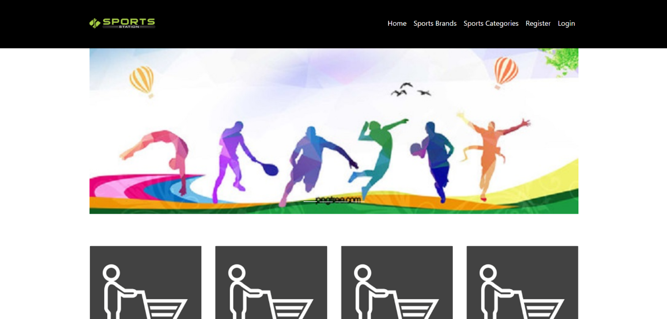

### Registration Page

With the help of this page, new registered visitor can sign up for the app

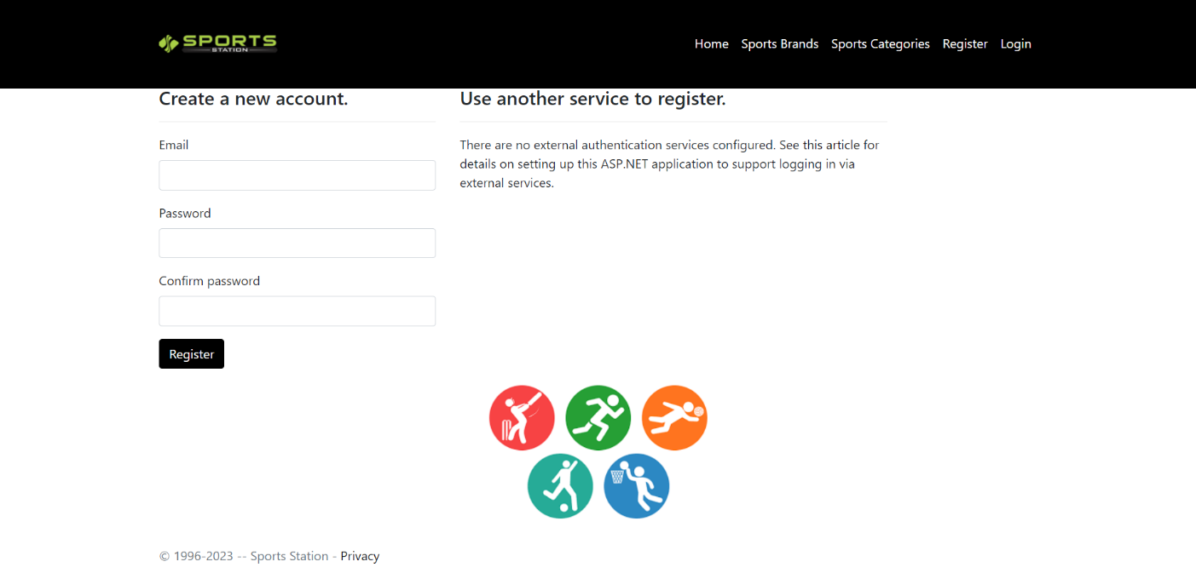

### Login Page

With the help of this page, registered visitor and admin can login to the application using their valid credentials.

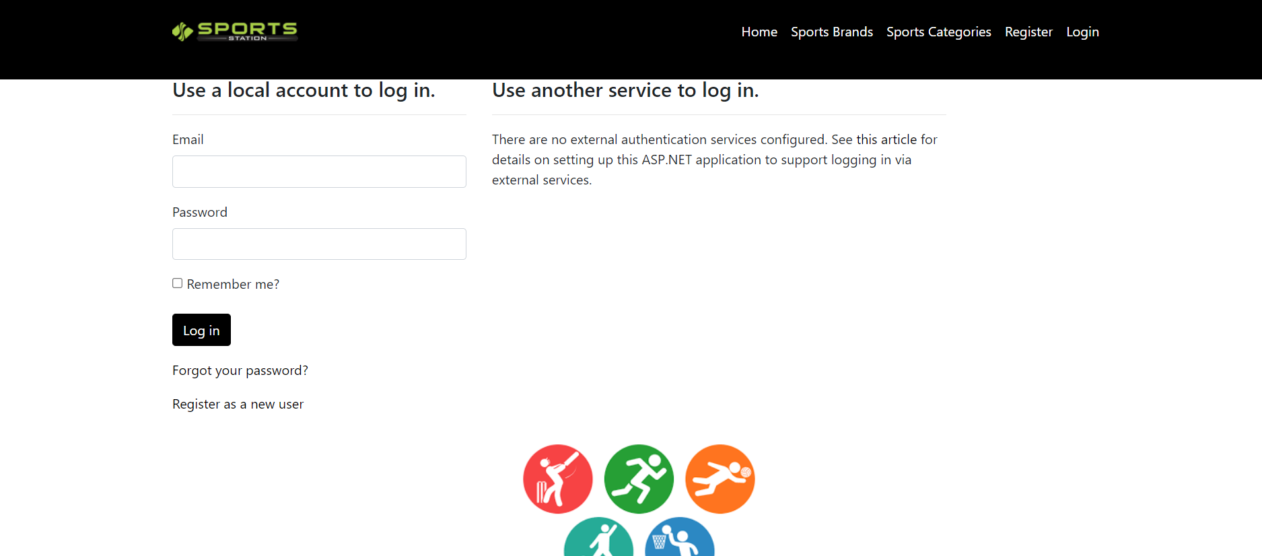

### Sports Material Admin View

This page highlights all the sports material available on the application. Admin can add new sports material Details, edit, delete and check details of the existing ones.

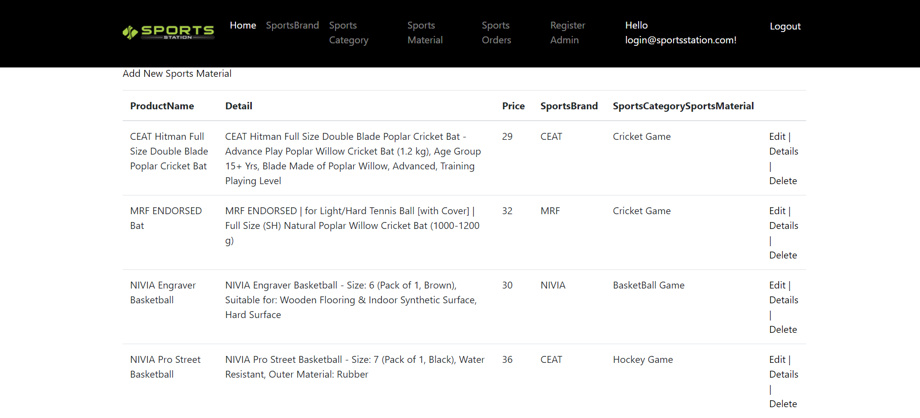

### Sports Categories Admin View

With the help of this page admin can manage the Sports Category details by editing, deleting and checking their details.

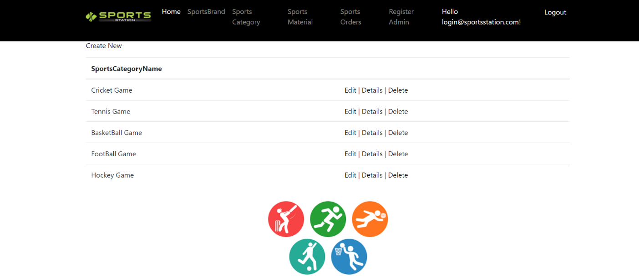

### All Sports Categories Visitor View

With the help of this page Visitor can view All Sports Categories details.

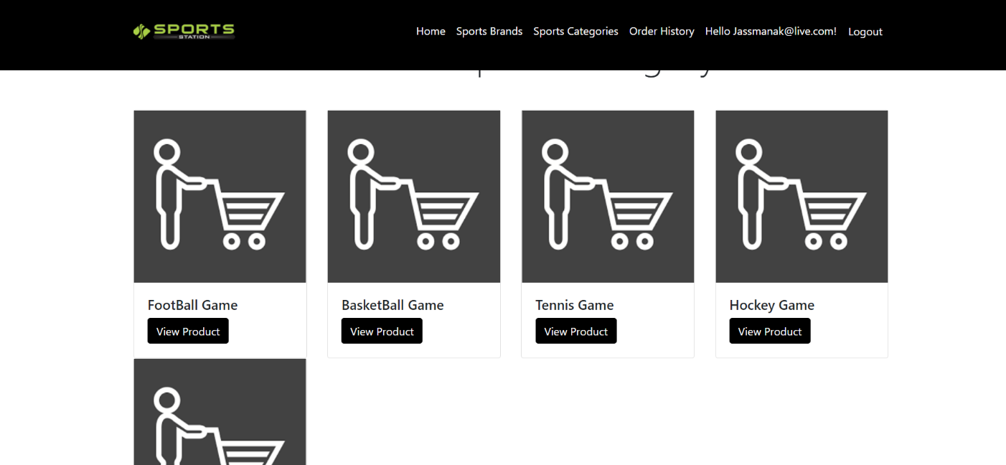

### All Sports material Visitor View

With the help of this page visitor can check the details of the Sports Material Details.

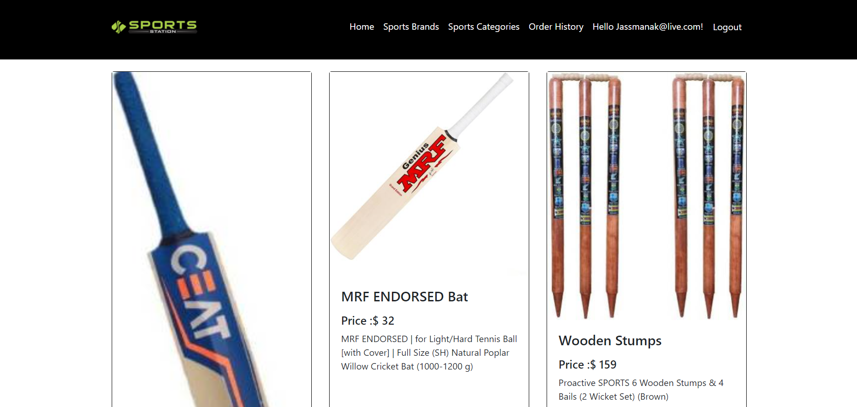

### Sports Order History Page Customer View

This page shows the All Order History performed by a specific user

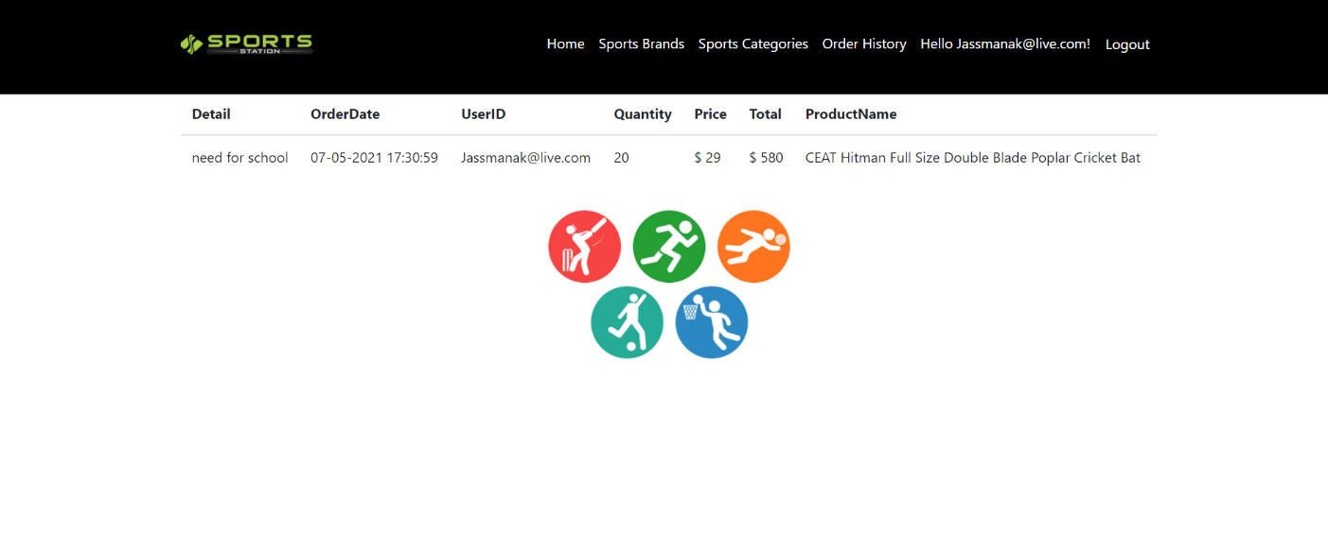

## 

## Project Testing

The testing file for usability testing is attached as [usability test.xlsx](usability%20test.xlsx)

# User Manual

The main purpose of the application Sports Station is to help people to all the sports playing material and they can also place a bulk order according to their requirement. In this application there are two types of users- admin and registered user or visitor customer. Admin has different functionalities as compare to customers. Admin can add, edit, delete and check details of sports categories, sports brands and sports material details. Also, registered user has authority to place bulk order.

## Summary

### System Configuration

This app will be useful to for providing an interface to showcase available sports playing material and way to place a bulk order.

### User Access Levels

Only registered users can access the features of this application.

* **Admin:** Admin has full access of the app can register new admins.
* **Registered Visitor:** New visitor can register and existing can login using their own credentials. They have limited access.